Project Design Phase Solution Architecture

Date | 28 September 2026
Team ID | 6ab2210011b716a3e52c62c6
Project Name | Streamlining IT Procurement: Automatic Standard Laptop Orders With Flow Designer
Maximum Marks | 4 Marks

Solution Architecture:
Solution architecture is a complex process – with many sub-processes – that bridges the gap between business problems and technology solutions. Its goals are to:
- Find the best tech solution to solve existing business problems.
- Describe the structure, characteristics, behaviour, and other aspects of the software to project stakeholders.
- Define features, development phases, and solution requirements.
- Provide specifications according to which the solution is defined, managed, and delivered.

Solution Architecture Diagram – Streamlining IT Procurement:
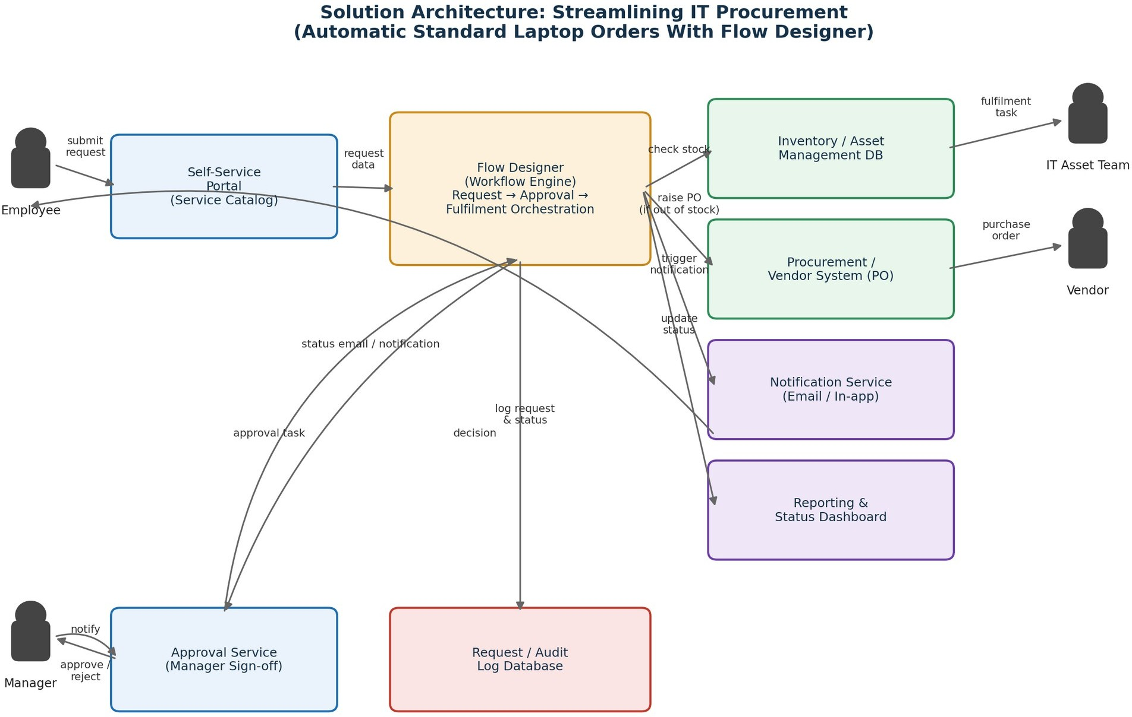

Figure 1: Architecture and data flow of the automated standard laptop order solution
Reference: https://www.servicenow.com/docs/r/application-development/flow-designer.html

